Daniel Beck

SDEV-325

August 31, 2020

1. The first software vulnerability that was addressed was CWE-787: Out-of-bounds Write in Java language. “Typically, this can result in corruption of data, a crash, or code execution. The software may modify an index or perform pointer arithmetic that references a memory location that is outside of the boundaries of the buffer. A subsequent write operation then produces undefined or unexpected results (*Common Weakness Enumeration,* 2020).” An example of this would be having an array that can only hold a certain amount of data, but the user tries to enter more information than the software is written to handle. 1a shows the error in a java program when the user tries to enter more than three numbers into an array. 1b shows the error being mitigated using a try/catch that catches the ArrayIndexOutOfBounds, prompting the user that they can not add more than three items.

2. The second software vulnerability that was addressed was CWE-20: Improper Input Validation in Python language. “Input validation is a frequently-used technique for checking potentially dangerous inputs in order to ensure that the inputs are safe processing within the code, or when communicating with other components. When software does not validate input properly, an attacker is able to craft the input in a form that is not expected by the rest of the application. This will lead to parts of the system receiving unintended input, which may result in altered control flow, arbitrary control of a resource, or arbitrary code execution (*Common Weakness Enumeration,* 2020).” An example of this would be at a register where the employee may accidentally type in a negative number and credit money onto the customers credit card. 2a shows the vulnerability being exposed that would allow a negative number to be entered into the system. 2b. show the vulnerability being mitigated by adding a try/except that raises a type error when a negative number is entered.

1a.

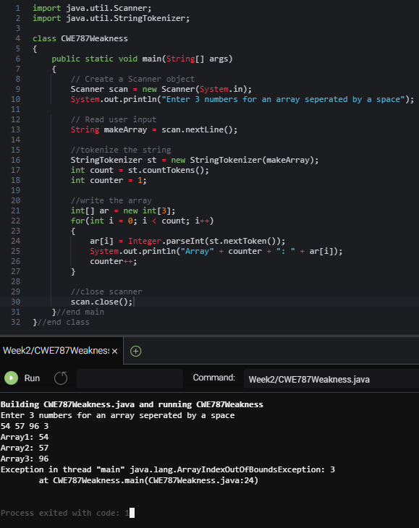

1b.

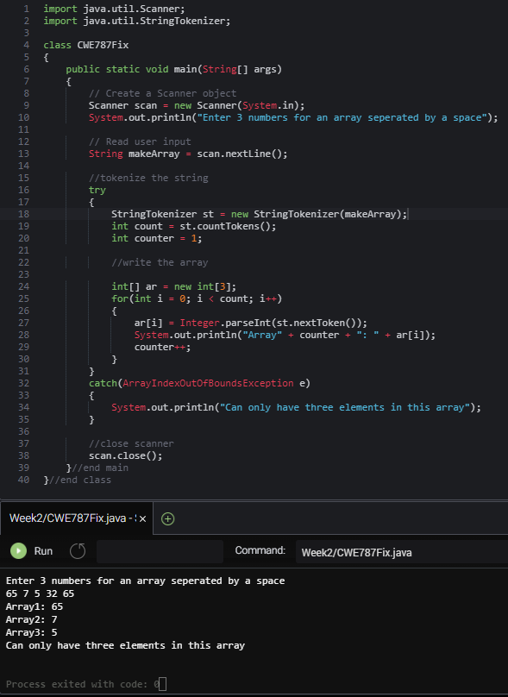

2a.

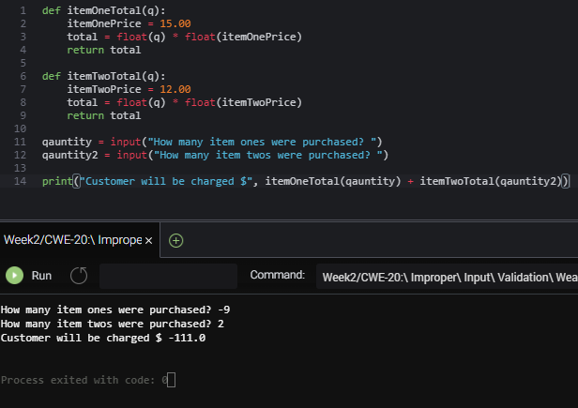

2b.

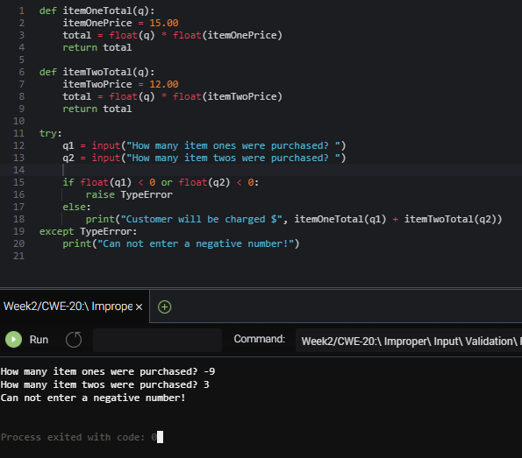

References:

Common Weakness Enumeration. (2020, August 20). Retrieved September 02, 2020, from https://cwe.mitre.org/data/definitions/